Write a C program to identify and eliminate dead code from a given sequence of
Three Address Code statements. Display the optimized code after removing statements
whose results are never used.
Example Input:
t1 = a + b
t2 = c * d
t3 = t1 + 10
x = t3
y = 20
PROGRAM CODE
#include <stdio.h>
#include <string.h>
#include <ctype.h>

#define MAX 100
#define LEN 100

char code[MAX][LEN];
char lhs[MAX][LEN];
char rhs[MAX][LEN];
int keep[MAX];

char live[MAX][LEN];
int liveCount = 0;

// Add a variable to the live list
void addLive(char name[]) {
for (int i = 0; i < liveCount; i++) {
if (strcmp(live[i], name) == 0)
return;
}

if (liveCount < MAX) {
strcpy(live[liveCount++], name);
}
}

// Remove a variable from the live list
void removeLive(char name[]) {
for (int i = 0; i < liveCount; i++) {
if (strcmp(live[i], name) == 0) {
for (int j = i; j < liveCount - 1; j++)
strcpy(live[j], live[j + 1]);

liveCount--;
return;
}
}
}

// Check whether a variable is live
int isLive(char name[]) {
for (int i = 0; i < liveCount; i++) {
if (strcmp(live[i], name) == 0)
return 1;
}

return 0;
}

// Find variable names in an expression
void addVariables(char text[]) {
int i = 0;

while (text[i] != '\0') {
if (isalpha((unsigned char)text[i]) ||
text[i] == '_') {

char name[LEN];
int j = 0;

while (isalnum((unsigned char)text[i]) ||
text[i] == '_') {
name[j++] = text[i++];
}

name[j] = '\0';
addLive(name);
} else {
i++;
}
}
}

int main() {
int n = 0;
char line[LEN];
char outputs[LEN];

printf("Enter Three Address Code ");
printf("(blank line to stop):\n");

while (n < MAX && fgets(line, sizeof(line), stdin)) {
if (line[0] == '\n' || line[0] == '\r')
break;

line[strcspn(line, "\r\n")] = '\0';

char *equal = strchr(line, '=');

if (equal == NULL) {
printf("Invalid statement: %s\n", line);
continue;
}

int start = 0;
int end = (int)(equal - line);

while (start < end &&
isspace((unsigned char)line[start]))
start++;

while (end > start &&
isspace((unsigned char)line[end - 1]))
end--;

int len = end - start;

if (len <= 0 || len >= LEN) {
printf("Invalid destination.\n");
continue;
}

strncpy(lhs[n], line + start, len);
lhs[n][len] = '\0';

strcpy(rhs[n], equal + 1);

start = 0;
while (isspace((unsigned char)rhs[n][start]))
start++;

if (start > 0)
memmove(rhs[n], rhs[n] + start,
strlen(rhs[n] + start) + 1);

strcpy(code[n], line);
keep[n] = 0;
n++;
}

printf("Enter output variables (example: x): ");
fgets(outputs, sizeof(outputs), stdin);

addVariables(outputs);

// Scan the statements from bottom to top
for (int i = n - 1; i >= 0; i--) {
if (isLive(lhs[i])) {
keep[i] = 1;

// The statement replaces the old value
removeLive(lhs[i]);

// Its input variables are now needed
addVariables(rhs[i]);
}
}

printf("\nOptimized Three Address Code:\n");

for (int i = 0; i < n; i++) {
if (keep[i])
printf("%s\n", code[i]);
}

return 0;
}
OUTPUT
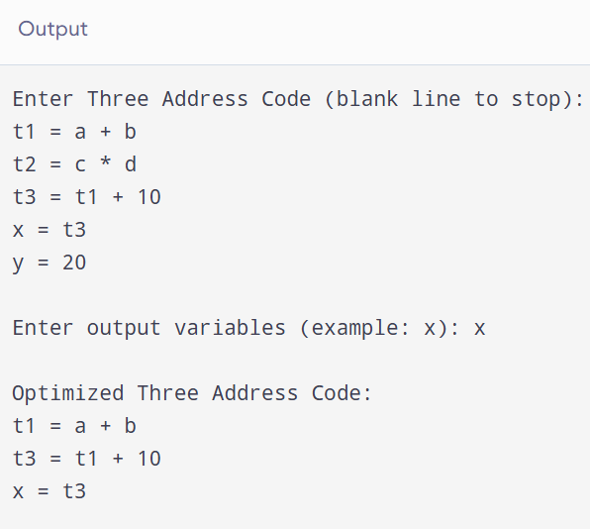S

